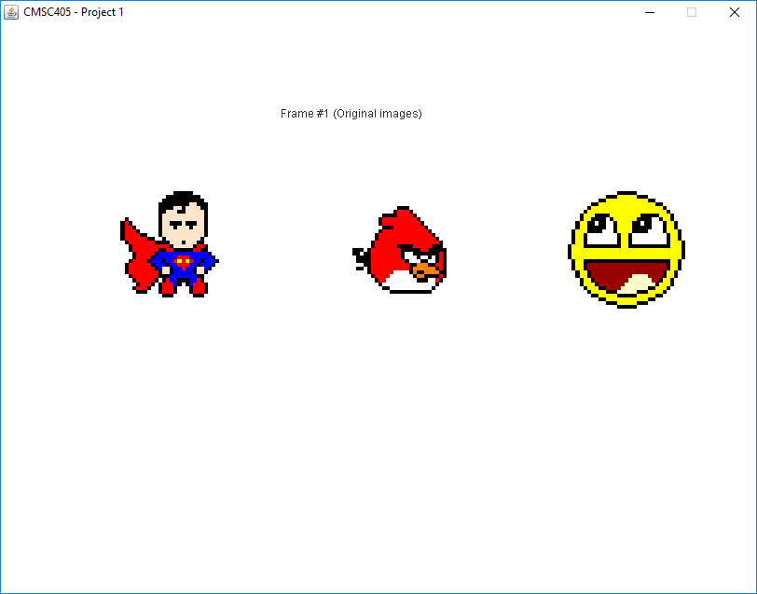

**Graphics2D – Project 1**

Steve Granger

CMSC 405 6980 Computer Graphics (2188)

Professor: Lauren King

Due: September 2, 2018 11:59 PM

**Summary**

The goal of Project 1 was to use the Java Graphics2D library to perform various graphical transformations on several two-dimensional graphic images, in an animated sequence. The template files “CMSC405P1Template.java” and “ImageTemplate.java” were provided by the instructor for this project, and were both used as a basis for my implementation of this project. Additional details on the project are provided in the “Project Requirements” section below.

**Project Requirements**

1. Using Netbeans or Eclipse, develop a Java 2D graphics application that creates 3 images. The images should have the following specifications:
   1. Size: minimum 25x25 pixels, larger images are Okay.
      1. **NOTE**: I used 31 x 31 images.
   2. Type: Color (consists of two or more colors)
   3. Simple form or shape.
      1. **NOTE**: I elected to create my own small bitmap images, created from arrays that were designed from some simple images I found online. References for these images are provided in this document’s reference section.
   4. Images should be generated inside of separate methods and stored as 2D arrays.
2. Use Java 2D graphics to display your original images.
3. For each image use the existing Java 2D graphics transformation methods to translate, rotate and scale each object. You should perform the following transformations on each image:
   1. Translate -5 in x direction, Translate +7 in the y direction.
      1. **NOTE**: I interpreted this requirement to mean translating the image 5 units to the left, and 7 units vertically up. This is consistent with the translation schema provided in the original project template.
   2. Rotate 45 degrees counter clockwise.
   3. Rotate 90 degrees clockwise.
   4. Scale 2 times for the x component, scale 0.5 times for the y component.
4. The following requirements apply to the transformations listed above:
   1. Each of these transformations should be displayed in sequence with the images always starting from the previous transformation as opposed to the original image.
   2. Use Java 2D graphics to display each transformation for each image, using the Project 1 template as a starting point for the project.

**Deliverables**

The following files have been provided to document completion of this project:

1. Source code:
   1. MainApplication.java. This class encapsulates the application GUI, and handles drawing of the original images and the associated graphical transforms. This file is based on the “CMSC405P1Template.java” source code file provided by the instructor.
   2. ImageTemplate.java. This class contains static methods for generation of the three images that are drawn and manipulated by the application. The file is based on the ImageTemplate file provided by the instructor.
2. Additional Documentation:
   1. SteveGrangerP1.pdf. This file, which contains the test documentation and project references.

**Compilation**

The following screen shot demonstrates successful compilation and startup of the source code for this project:

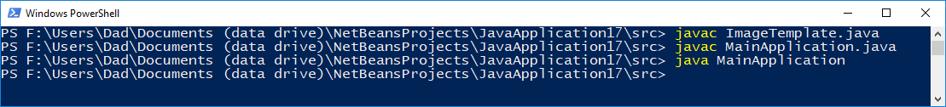

**Test Plan**

|  |  |  |  |  |
| --- | --- | --- | --- | --- |
| **Case** | **Input** | **Expected Output** | **Actual Output** | **Pass / Fail** |
| 1 | Start application | A window appears in the center of the screen | A window appears in the center of the screen | Pass |
| Window is titled “CMSC405 – Project 1” | Window is titled “CMSC405 – Project 1” | Pass |
| Three different 31 x 31 images appear within the window | Three different 31 x 31 images appear within the window | Pass |
| All images appear in normal, unaltered state. | All images appear in normal, unaltered state. | Pass |
| Window background is white. | Window background is white. |  |
| Window contains a caption that reads “Frame #1 (Original images)” | Window contains a caption that reads “Frame #1 (Original images)” | Pass |
| 2 | Wait approximately two seconds | Previous images are erased, and re-drawn with an offset of -5 in the X-direction (i.e. 5 units left), and +7 in the Y direction (i.e., 7 units up) relative to the original image. | Previous images are erased, and re-drawn with an offset of -5 in the X-direction (i.e. 5 units left), and +7 in the Y direction (i.e., 7 units up) relative to the original image. | Pass |
| Window contains a caption that reads “Frame #2 (translated -5 in X direction, +7 in Y direction” | Window contains a caption that reads “Frame #2 (translated -5 in X direction, +7 in Y direction” | Pass |
| 3 | Wait approximately two seconds | Previous images are erased, and re-drawn as rotated 45 degrees counter-clockwise relative to the previous image positions. | Previous images are erased, and re-drawn as rotated 45 degrees counter-clockwise relative to the previous image positions. | Pass |
| Window contains a caption that reads “Frame #3 (rotated 45 degrees counter-clockwise)” | Window contains a caption that reads “Frame #3 (rotated 45 degrees counter-clockwise)” | Pass |
| 4 | Wait approximately two seconds | Previous images are erased, and re-drawn as rotated 90 degrees counter-clockwise relative to the previous image positions. | Previous images are erased, and re-drawn as rotated 90 degrees counter-clockwise relative to the previous image positions. | Pass |
| Window contains a caption that reads “Frame #4 (rotated another 90 degrees clockwise)” | Window contains a caption that reads “Frame #4 (rotated another 90 degrees clockwise)” | Pass |

**Test Plan (Continued)**

|  |  |  |  |  |
| --- | --- | --- | --- | --- |
| **Case** | **Input** | **Expected Output** | **Actual Output** | **Pass / Fail** |
| 5 | Wait approximately two seconds | Previous images are erased, and re-drawn scaled at 2x in X-direction and 0.5X in Y direction relative to previous images. | Previous images are erased, and re-drawn scaled at 2x in X-direction and 0.5X in Y direction relative to previous images. | Pass |
| Window contains a caption that reads “Frame #5 (scaled 2 times in X direction, 0.5x for Y direction” | Window contains a caption that reads “Frame #5 (scaled 2 times in X direction, 0.5x for Y direction” | Pass |
| 6 | Wait approximately two seconds | Previous images are erased, and re-drawn in original locations and at original shapes / orientations. | Previous images are erased, and re-drawn in original locations and at original shapes / orientations. | Pass |
| Window contains a caption that reads “Frame #1 (Original images)” | Window contains a caption that reads “Frame #1 (Original images)” | Pass |
| 7 | Press “close” button on main window of application | Application closes & exits | Application closes & exits | Pass |

**Screen Shots from Test Plan**

Test Case 1



**Screen Shots from Test Plan (Continued)**

Test Case 2

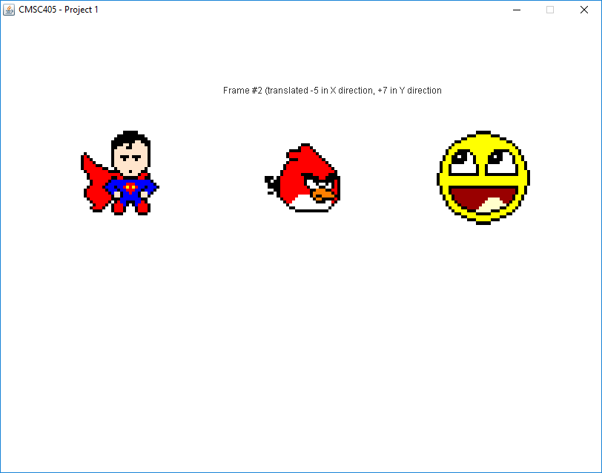

**Screen Shots from Test Plan (Continued)**

Test Case 3

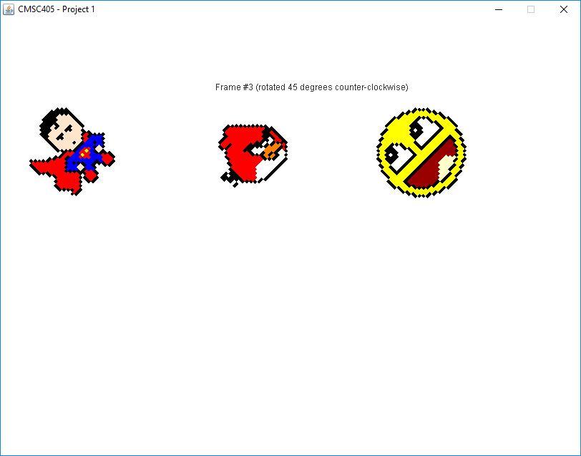

**Screen Shots from Test Plan (Continued)**

Test Case 4

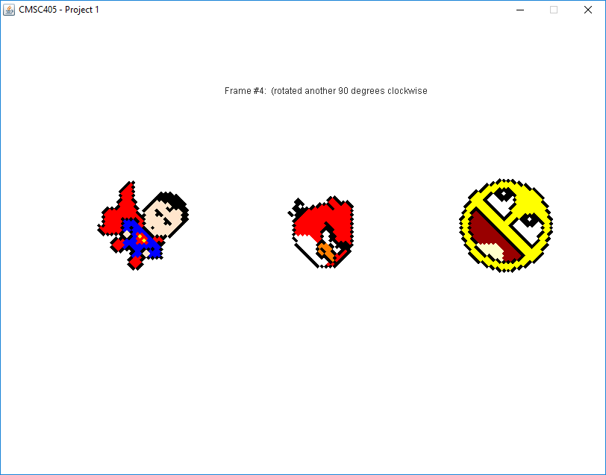

**Screen Shots from Test Plan (Continued)**

Test Case 5

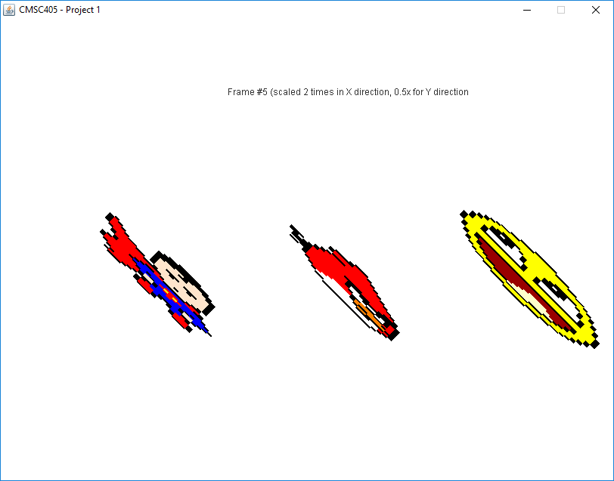

**Screen Shots from Test Plan (Continued)**

Test Case 6



NOTE: No screen shot provided for test case #7, since application is closed at this point (so there is nothing to show).

**References**

* UMUC (n.d.). *Project 1 instructions*. Retrieved from: <https://learn.umuc.edu/d2l/common/viewFile.d2lfile/Database/MTMwNjg0NTQ/Project%201.pdf?ou=325460>
* UMUC (n.d.). *Project 1 template files*. Retrieved from: <https://learn.umuc.edu/d2l/le/news/widget/325460/FileProvider?newsId=1275264&fileId=13366926>
* RapidTables (n.d.). *RGB Color Codes Chart*. Retrieved from: <https://www.rapidtables.com/web/color/RGB_Color.html>
* Pinterest (n.d.) *Smiley Face Image on Grid*. Retrieved from: <https://i.pinimg.com/originals/a7/21/a9/a721a91dad172c5cb5fcaaeee5b2bc04.png>
* Minecraft Building, Inc. (n.d.) *Angry Bird Image on Grid*. Retrieved from: <https://minecraftbuildinginc.com/wp-content/uploads/2013/06/Angry-Bird-Red-Minecraft-Template-Finish.png>
* Shopify.com (n.d.). *Superman Image on Grid*. Retrieved from: <http://cdn.shopify.com/s/files/1/0822/1983/articles/superman-pixel-art-pixel-art-superman-fictional-character-superhero-dc-comics-man-of-steel-pixel-8bit.png?v=1501228451>